＜Fellowship Report＞
Clinical 3D Printing and Orthopaedic Trauma Fellowship Program
Queen Mary Hospital, The University of Hong Kong

Yosuke Nagai, MD
Department of Orthopaedic Surgery, Osaka Metropolitan University

1. Introduction
I had the opportunity to join the Clinical 3D Printing and Orthopaedic Trauma Fellowship Program at the Department of Orthopaedic and Traumatology, The University of Hong Kong (HKU). During this time, I also worked as a clinical associate at Queen Mary Hospital (QMH).
The fellowship program blends trauma care with 3D printing technology, providing advanced experience in both clinical practice and research.

2. Team Structure and Organization
The fellowship was conducted within the trauma team at HKU under the guidance of Professor Frankie Leung and led by Dr. Christian Fang.
The team was highly organized and seamlessly integrated clinical practice, teaching, and research. The system worked efficiently and stably with the support of motivated residents. Dr. Colin Yung's leadership and coordination skills were very impressive for his generation.
Orthopedic trauma surgery was performed almost daily and there were abundant hands-on clinical opportunities.
In addition to outpatient and perioperative care, we attended conferences and 3D printing meetings to gain a comprehensive understanding of the entire clinical workflow.
The team atmosphere was open, collaborative, educational, and supportive. In particular, we would like to thank Ms. Doris Lau for her tremendous support over the long term.

3. Clinical Experience
One of the most striking features of the fellowship was the large number and diversity of trauma cases.
The cases included:
・Fragility fractures, especially hip fractures in the elderly
・Acute and delayed/complex trauma
・A wide range of trauma involving both upper and lower extremities
We were actively involved in the clinical management of these cases.

I was particularly impressed by
・how trauma care functions as a true team medicine.
・There is a systematic system that integrates from preoperative assessment to postoperative rehabilitation.
I realized that trauma care is not just dependent on surgical skills, but is supported by a well-designed system as well as individual skills.

4. 3D Printing and Research
An important feature of this program is the integration of 3D printing into clinical practice.
I was involved in the whole process:
・Patient-specific implant design
・Preoperative simulation
・Interdisciplinary discussion with bioengineers
・Application to actual surgery
In addition, we experienced a tour of the manufacturing facility and gained a deep understanding of how design and clinical application work closely together.
During the regular 3D printing meetings, clinicians and engineers sat together to discuss cases and understand how surgery and engineering work as a continuous and integrated process.

5. Mentorship and Education
Dr. Christian Fang is an excellent surgeon with an enthusiastic and innovative approach to education. His ability to concisely explain complex procedures based on essential principles was particularly impressive.
Through interactions such as:
・Discussions with residents
・Joint conferences with other teams and institutions
・Participation in collaborative research
・Collaboration with allied health professions
We were able to gain a broader and more comprehensive perspective on trauma care.

6. Life in Hong Kong
We stayed in the convenient Sheung Wan district.
In our free time, we
・strolled around the city
・experienced local cuisine
・visited Macau
and enjoyed clinical learning as well as cultural enrichment.

7. Conclusion
Through this fellowship, We gained valuable knowledge about
・systems-based trauma care
・Importance of team medicine
・Clinical application of advanced technologies such as 3D printing

We realized that the quality of medical care is determined not only by individual technology but also by the system that supports it.
We hope to utilize these experiences in clinical practice, research, and education in the future.
This fellowship program is highly valuable and highly recommended for orthopedic surgeons interested in trauma medicine and 3D printing.

8. Acknowledgments
We would like to express our sincere gratitude to Professor Frankie Leung, Dr. Christian Fang, Dr. Colin Yung, and the staff at QMH and HKU. We are also very grateful to all the people who supported us during our stay.

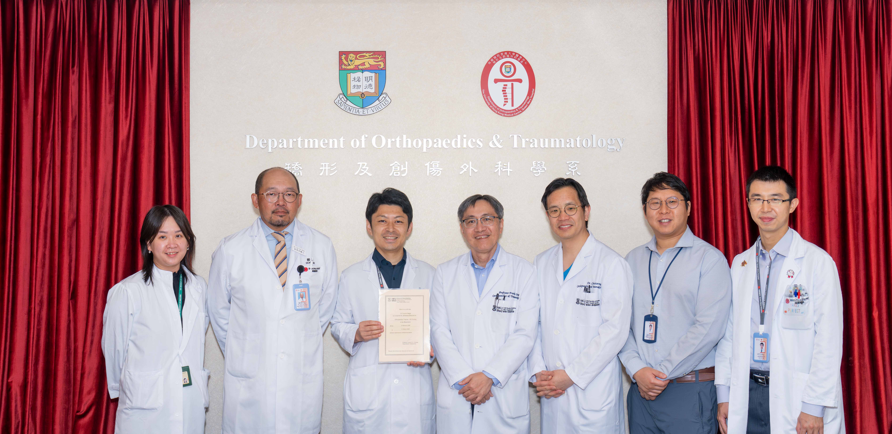
with the O&T team

 views from my walk

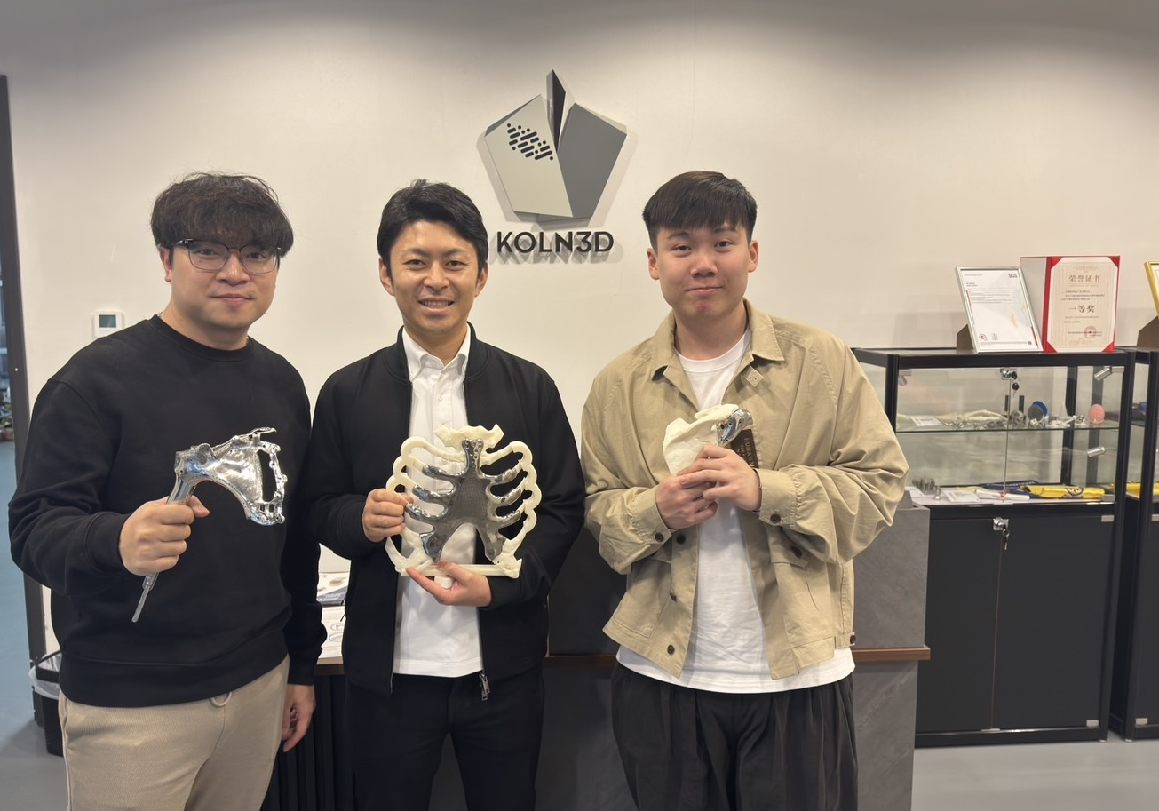
Great visit to the metal company — thanks to Jeffery Lung.

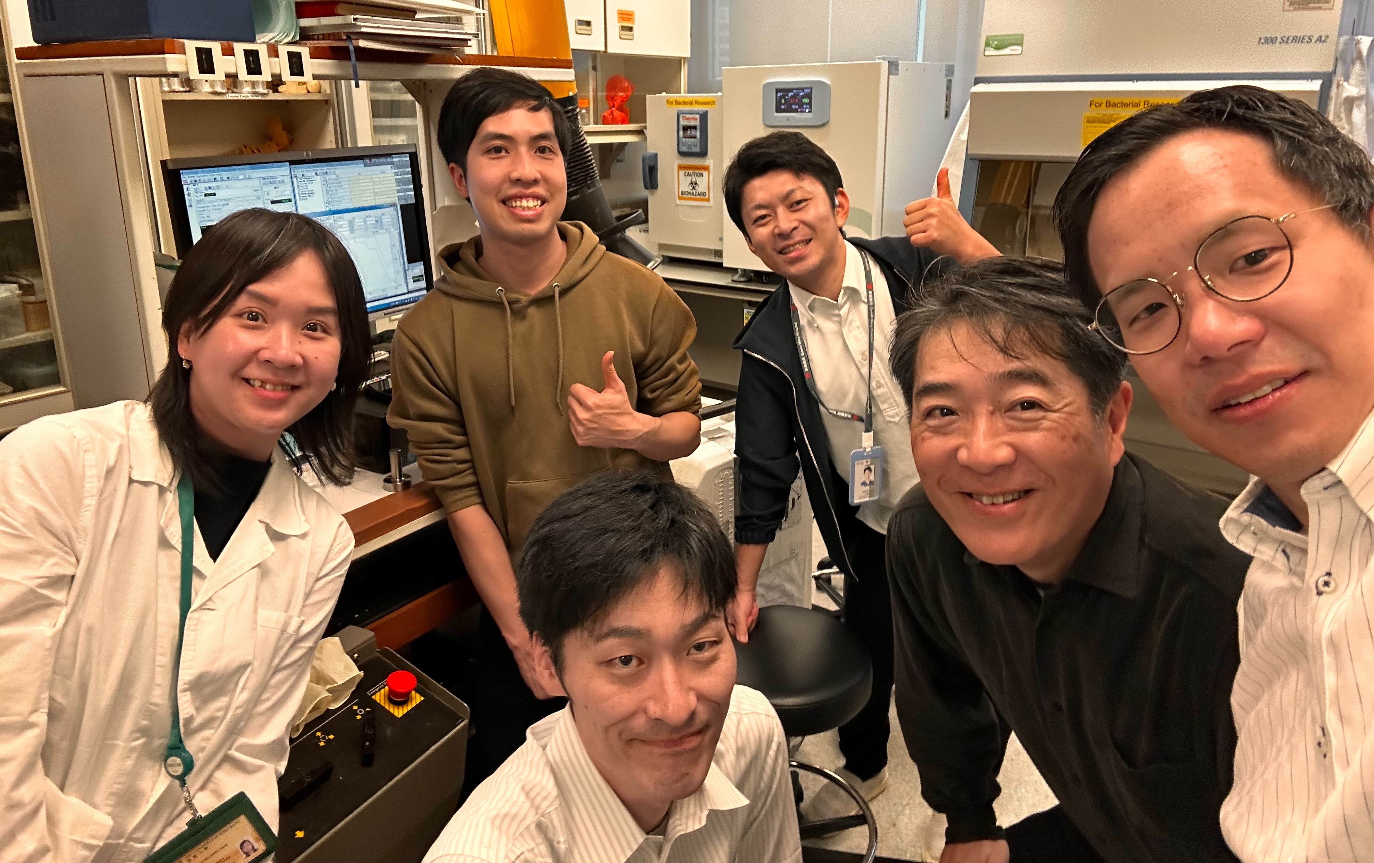
collaborative research with the Japanese team

